Sri Lanka Institute of Information

Technology



Lab Submission

<Lab sheet No 08>

**<IT24100800>**

**<Rajapaksha A.G.S>**

**IT2120 - Probability and Statistics**

B.Sc. (Hons) in Information Technology

Exercise

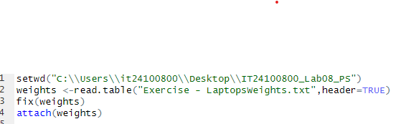

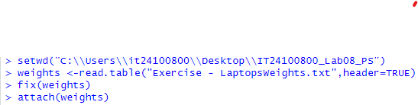

**Q1**

**Q2**

**Q3**

